

**NAME:** Muhammad Talha Ansari

**SUBJECT:** Digital logic design

**ROLL NO# 024**

**ASSINGED BY:** sir Rafay

**(SOP) BOOLEAN EXPRESSION**

* 1. F1(A,B,C) = A’B’C + BC’ + AC’

= ~AB~C + B~C (A+~A) + A~C (B+~B)

= ~ A~BC + AB~C + ~AB~C + AB~C + A~B~C

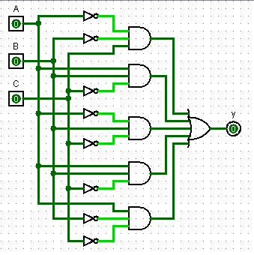 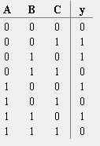

1. F2(A,B,C) = AB’C’ + AC’ + B’C’

= A B ~C + A ~C ( B + ~B ) + B ~C ( A + ~A )

= A B ~C + A B ~C + A ~B ~C + A ~B ~C + ~A ~B ~C

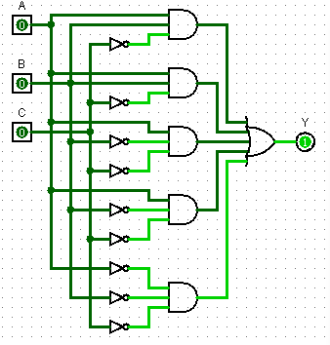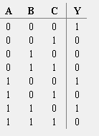

iii f3 (ABCD)= ~A~B~C~D + AB~C + A~C

= ~A~B~C~D + AB~C (D+~D) + A~C(B+~B) (D+~D)

= ~A~B~C~D + AB~CD + AB~CD + AB~C(D+~D) + A~B~C (D+~D)

= ~A~B~C~D +AB~CD +AB~C~D +AB~CD +AB~C~D +A~B~CD+~A~B~C~D

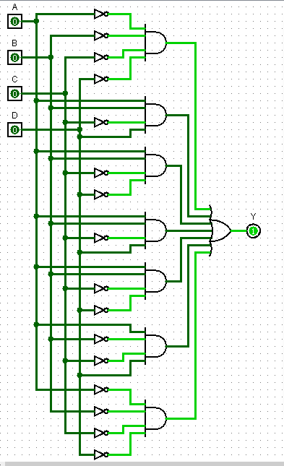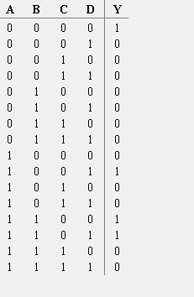

**(POS) BOOLEAN EXPRESSION**

(iv) F(ABC)= (~A+~B+C) (B+~C) (A+~C)

= (~A+~B+C) ( B+~C) (A.~A)(A+~C) (B.~B)

= (~A+~B+C)(A+B+~C)(~A+B+~C)(A+B+~C)(A+~B+~C)

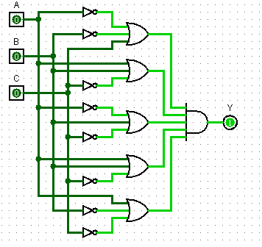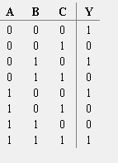

(v) F(ABC) = (A+B)(A+C) (B+C)

= (A+~B)( C+~C) (A+~C)(B+~B) (B+~C)(A+~A)

= (A+~B+C) (A+~B+C) (A+~C+B) (A+~C+~B) (B+~C+A) (B+~C+A)

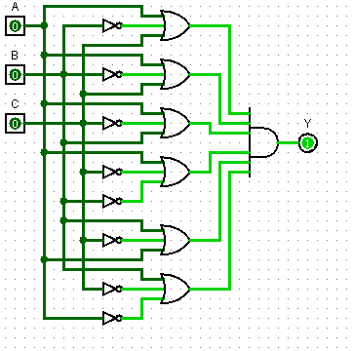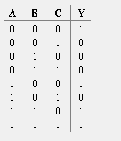

F(ABCD)=(~A+~B+C+D)(B+~C+D)(A+~C)

= (~A+~B+C+D)(A.~A)(B+~C+D)(B.~B)(A+~C)

=~(A+~B+C+D)(AB+A~C+AD)(~AB+~A~C+~AD)(BA+B~C)(~BA+~B~C)(D.~D)

= (~A+~B+C+D)(AB+A~C+AD)(~AB+~A~C+~AD)(BA+B~C)(~BAD+~B~CD)(~BA~D+~B~C~D)

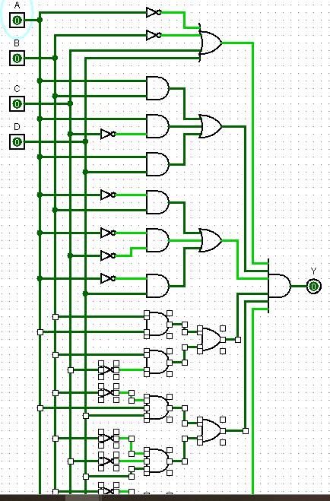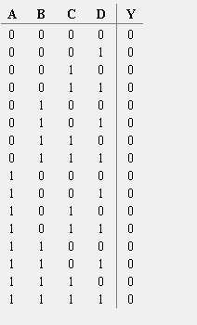

**Q#1 Why do we convert SOF & POS into their Canonical form?**

ANS:

Canonical Form (Standard SOP and POS Form) **Any Boolean function that is expressed as a sum of minterms or as a product of max terms** is said to be in its “canonical form

**Q#2 What is Combinational Analysis?**

ANS: All circuits fall into one of two well-known categories: In a combinational circuit, all circuit outputs are a strict combination of the current circuit inputs.

**Q#3 What are minterms and Maxterms?**

ANS: A minterm is a Boolean AND function containing exactly one instance of each input variable or its inverse. A maxterm is a Boolean OR function with exactly one instance of each variable or its inverse. For a combinational logic circuit with n input variables, there are 2 n possible minterms and 2 n possible maxterms.